

***Durable furniture***

**E-Project Documentation**

**Teacher Name : Sir Aijaz laghari**

**APTECH COMPUTER EDUCATION**

**HYDERABAD-1 PAKISTAN**

**Issue Date : 16-03-2023**

TABLE OF CONTENT

|  |  |  |
| --- | --- | --- |
| **S No** | **Contents** | **Page No** |
| 01 | Certificate | 03 |
| 02 | Acknowledgement | 1 |
| 03 | Project Report | 1 |
| 04 | Problem Definition | 1 |
| 05 | Customer Requirements Specification  (CRS) | 1 |
| 06 | Architecture Design of the Project | 9 |
| 07 | System Requirement | 10 |
| 08 | Task Sheet | 11 |
| 09 | Project Plan | 13 |
| 10 | Checklist of work Progress | 14 |
|  |  |  |
| 11 | Screen Shots | 15 |
| 12 | Source Code | 19 |

CERTIFICATE

This is to certify that

**Bilal khan**

Has successfully Designed

Durable Furniture

Submitted by:

**Bilal khan**

Date of Issue: 16-03-2023

**Authorized Signature:** Sir Aijaz Ali

CERTIFICATE

This is to certify that

**Ibrar ali**

Has successfully Designed

Durable Furniture

Submitted by:

**Ibrar ali**

Date of Issue: 16-03-2023

**Authorized Signature:** Sir Aijaz Ali

CERTIFICATE

This is to certify that

**Asad Jaffry**

Has successfully Designed

Durable Furniture

Submitted by:

**Asad Jaffry**

Date of Issue: 16-03-2023

**Authorized Signature:** Sir Aijaz Ali

ACKNOWLEDGEMENT

First and foremost, we would like to express our deep gratitude and most heartfelt thanks to almighty ALLAH for his blessings, for lightening up our heart with the torch of knowledge and for giving us the ability to complete this project.

We would like to thanks Aptech Worldwide and the team of E-Project for their generous support and clarifying the doubts regarding e-project. We would like to acknowledge the way of explanation which the team of e-project gave in e-project to make website and we are equally grateful to our teacher (Sir Aijaz Ali) for giving us a moral support and guiding us different matters regarding project in all the time about the research and writing of this project.

We are greatly indebted to Aptech Worldwide, Sir Aijaz Ali, Faculty Members and ACE Hyderabad, Pakistan for encouragement and incessant help.

PROJECT REPORT

**BY:**

**Bilal Khan**

**Project Title : Durable Furniture,**

**Members Name : Bilal khan,**

**Batch Code : 2210E**

**Start Date : 16- 03-2023**

**End Date : 07-04-2023**

**Course : ACCP (HDSE)**

**Teacher : Sir Aijaz Ali**

**Center Manager : sir Salman**

**Center Academic Head : Sir Shoaib Ahmed**

**Center Name : ACE Hyderabad-1, Pakistan**

Submitted as

E Project Documentation

**PROBLEM DEFINITION**

Durable Furniture is the leading store of branded and designer for home.

The Furniture has tie up with various designers whose collection is on their display.

Also different apparel, accessories collection is also available with the store. The

website must be designed for this Furniture showing the collection of

various brands, designer. A website needs to be developing for the Furniture which must display all the collection. So taking into consideration the expanding business, the company planned to host the primary information via **Fun zone.com,** an Internet Gateway.

**Customer Requirement Specification**

The Web site is to be created based on the following requirements.

1) The Home Page should be created making use of sections with a suitable

logo.

2) Collection must be made more categorized as per the designers and types of

attire.

3) Color combination must be made more précised in the application so that

clothes must be properly highlighted.

4) Navigation needs to be smoother.

5) Comparison of different brands must be included in the website.

6) Gallery section of the Furniture must be included.

7) The look and feel of the project must be made user friendly and uniformity in

the color combination must be maintained.

8) About us, Contact Us (address and map) must be added.

9) Images must be added with its alt attribute defined.

PROJECT OBJECTIVE:

The Objective of this program is to give a sample project to work on real life

projects. These applications help you build a larger more robust application.

The objective is not to teach you JavaScript/Dreamweaver but to provide you with a

real life scenario and help you create basic applications using the tools.

You can revise the chapters before you start with the project.

This project is meant for students who have completed the module of

Dreamweaver. These programs should be done in the Lab sessions with assistance

of the faculty if required.

It is very essential that a student has a clear understanding of the subject. Students

should go through the project and solve the assignments as per requirements given.

Kindly get back to eProjects Team in case of any doubts regarding the application or

its objectives.

Architecture & Design of the Project:

Since the website will have client server architecture it will have one-tier architecture.

System Requirement:

|  |  |  |
| --- | --- | --- |
| **SR.No** | **Items** | **Description** |
| 01 | Operating System | Window XP, Win7 or win8 or win10 |
| 02 | Main Processor | Minimum 2ghz or better |
| 03 | Ram (Memory) | Minimum 512mb or better |
| 04 | Web Browser | Google Chrome or Firefox (Latest) |
| 05 | Software | Vs code , HTML editor, Adobe Dreamweaver CS5.5 |

TASK SHEET

|  |  |  |  |  |  |
| --- | --- | --- | --- | --- | --- |
| **Project Ref. No:** | | **Date of Preparation of Activity Plan:** | | | |
| SR.  No | Task | Actual  Start  Date: | Actual  Day: | Team  Mates  Names: | Status: |
| 01 | Planing | 18-03-2023 | 1 | Bilal khan | YES |
| 02 | Data  Collection | 19-03-2023 | 1 | Bilal khan | YES |
| 03 | Designing  Home  Page | 21-03-2023 | 4 | Bilal Khan | YES |
| 04 | Linking | 23-03-2023 | 9 | Asad jaffry | YES |
| 05 | Check  Links | 25-03-2023 | 2 | Bilal khan | YES |
| 06 | Finalizing | 26-03-2023 | 3 | Ibrar Ali | YES |
| 07 | Testing | 28-03-2023 | 2 | Bilal Khan | YES |
| 08 | Documentation | 29-03-2023 | 1 | Ibrar Ali | YES |
| 09 | Uploading | 31-03-2023 | 2 | Asad Jaffry | YES |

PROJECT PLAN

* Website is able to execute quickly.
* The color scheme of the site looks attractive.
* The collection of data is authentic and taken by the most popular product websites.
* There is authentic information of facilities products with their specifications.
* Background is different to main page.
* The HOME is well prepared exactly for the same page as user clicks on the link..
* A visitor can also view the individual image of our every gallery.

CHECK LIST OF WORK PROGRESS

|  |  |  |
| --- | --- | --- |
| **SR.No** | **Aspect Tested** | **Remarks** |
| 01 | Data Collection | **Yes** |
| 02 | Designing Home Page | **Yes** |
| 05 | Linking The Pages | **Yes** |
| 06 | Finalization | **Yes** |
| 08 | Tasting The Site | **Yes** |
| 09 | Documentation | **Yes** |

SCREEN SHOTS

Home-page-1

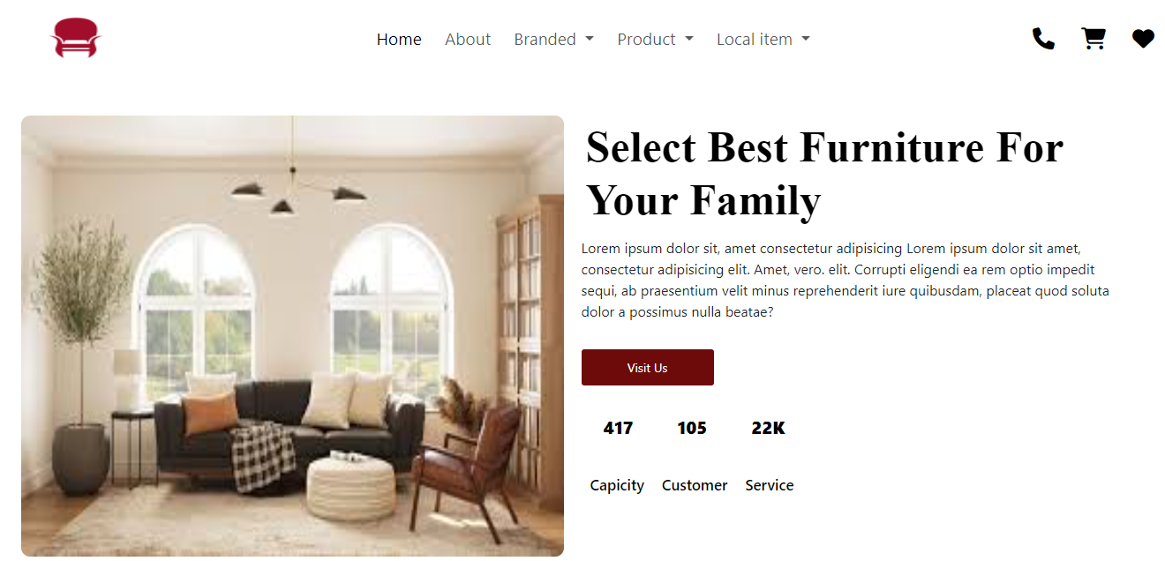

Home-page-2

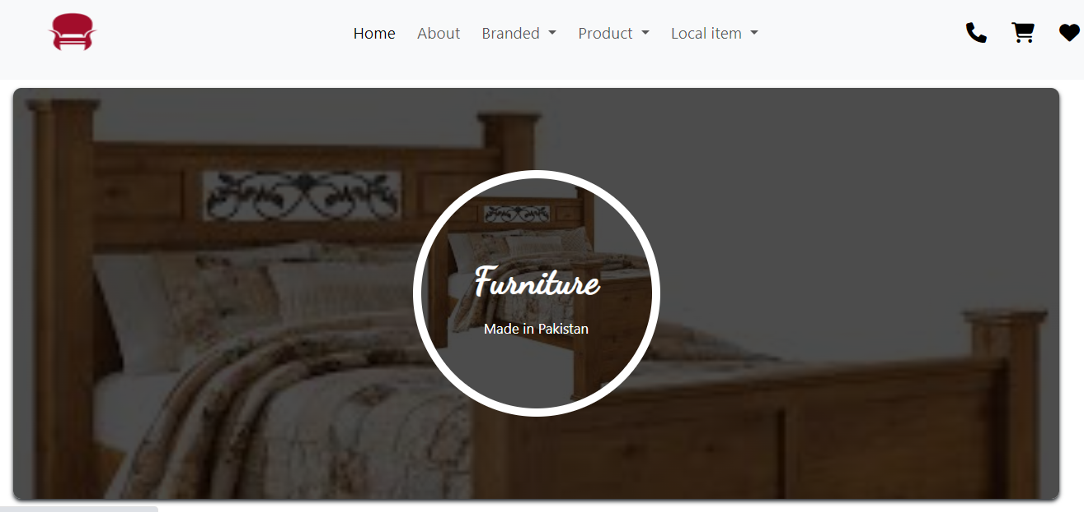

Home-page-3

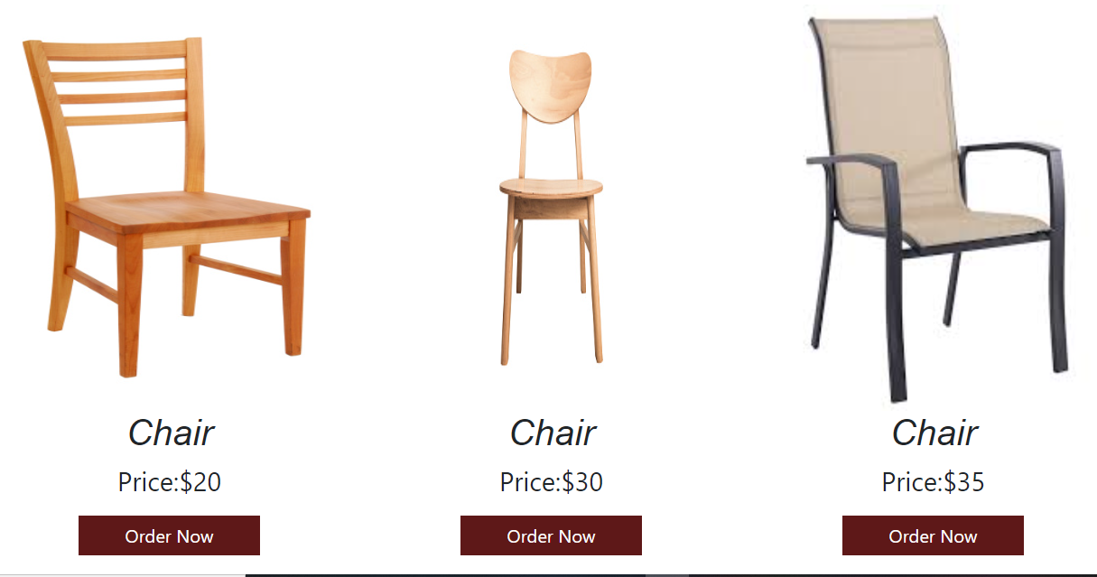

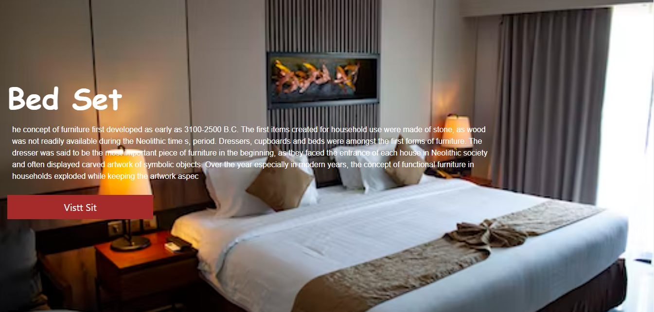

Home-page-4

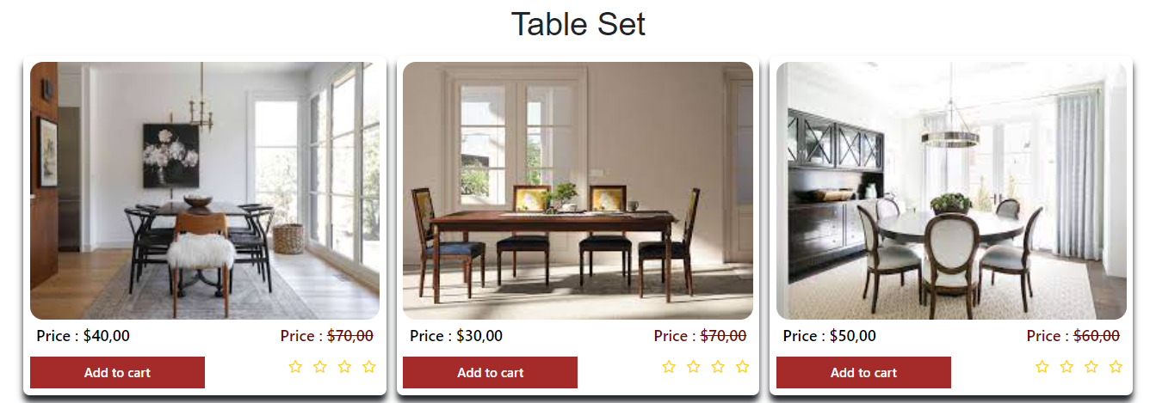

Home-page-5

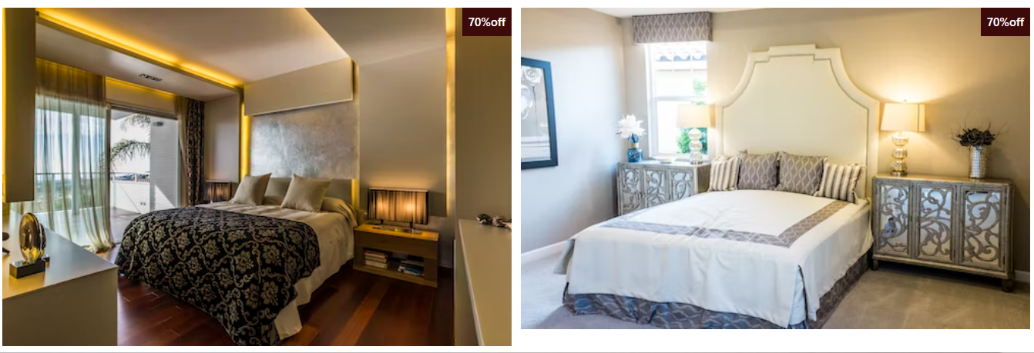

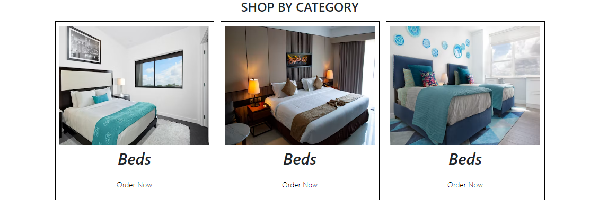

Home-page-6

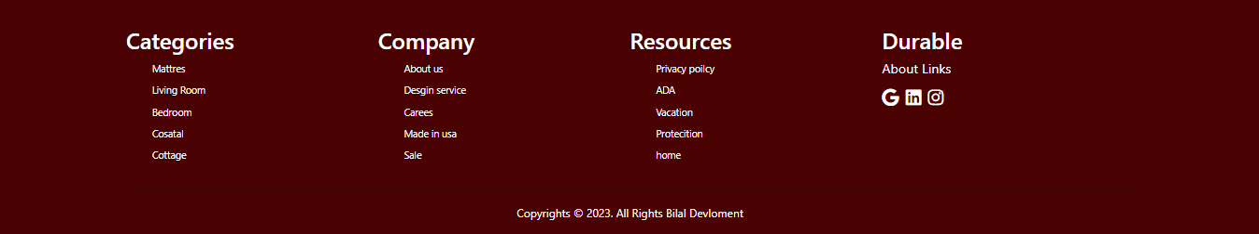

Category Page

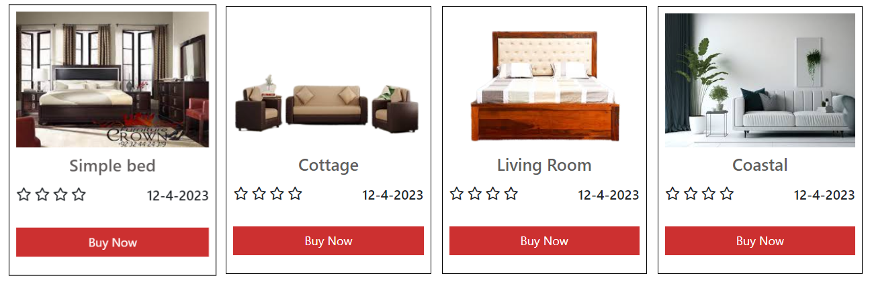

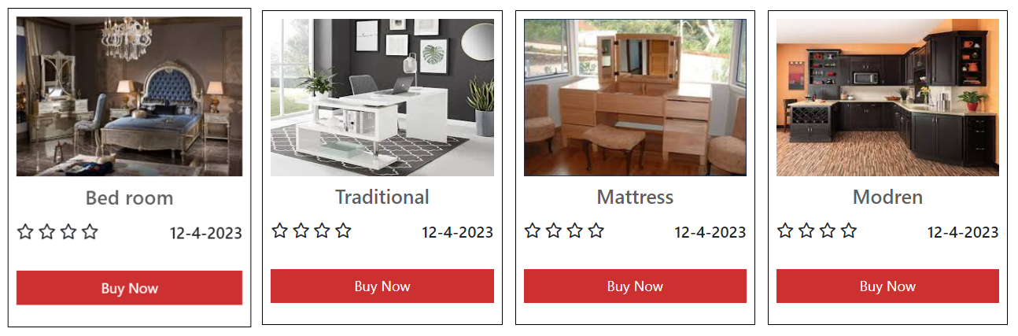

Contact-us

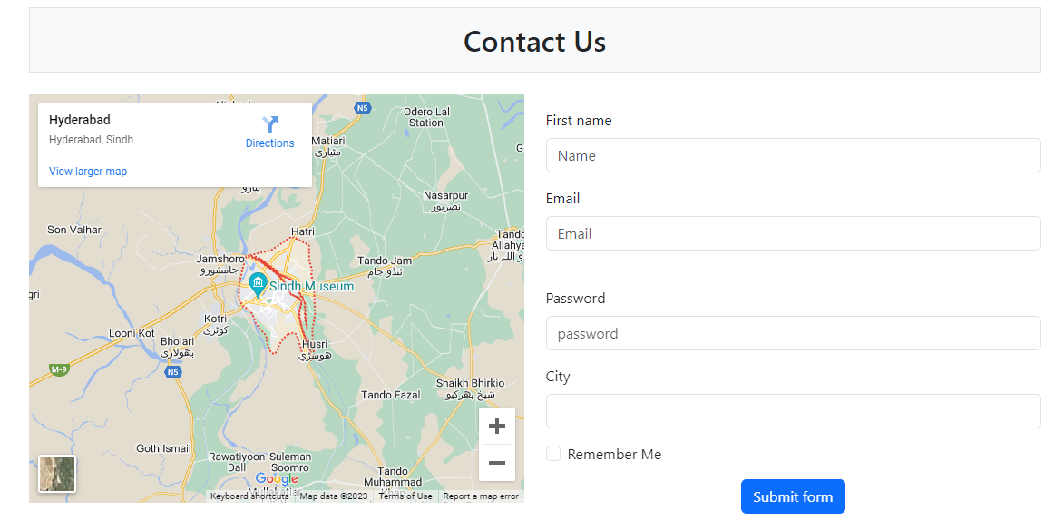

Product-page

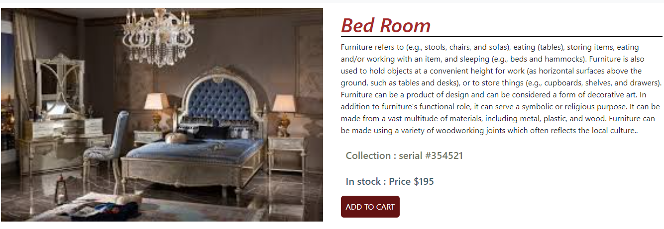

SOURCE CODE

<!DOCTYPE html>

<html lang="en">

<head>

  <meta charset="UTF-8">

  <meta http-equiv="X-UA-Compatible" content="IE=edge">

  <meta name="viewport" content="width=device-width, initial-scale=1.0">

  <title>Durable Fruniture</title>

  <link rel="stylesheet" href="https://cdnjs.cloudflare.com/ajax/libs/font-awesome/6.3.0/css/all.min.css"

    integrity="sha512-SzlrxWUlpfuzQ+pcUCosxcglQRNAq/DZjVsC0lE40xsADsfeQoEypE+enwcOiGjk/bSuGGKHEyjSoQ1zVisanQ=="

    crossorigin="anonymous" referrerpolicy="no-referrer" />

  <link rel="stylesheet" href="style.css">

</head>

<link href="https://cdn.jsdelivr.net/npm/bootstrap@5.3.0-alpha1/dist/css/bootstrap.min.css" rel="stylesheet"

  integrity="sha384-GLhlTQ8iRABdZLl6O3oVMWSktQOp6b7In1Zl3/Jr59b6EGGoI1aFkw7cmDA6j6gD" crossorigin="anonymous">

<body>

<script src="https://cdn.jsdelivr.net/npm/bootstrap@5.3.0-alpha1/dist/js/bootstrap.bundle.min.js" integrity="sha384-

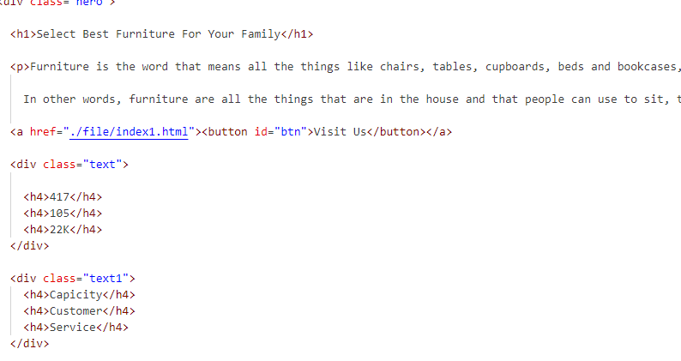

w76AqPfDkMBDXo30jS1Sgez6pr3x5MlQ1ZAGC+nuZB+EYdgRZgiwxhTBTkF7CXvN" crossorigin="anonymous"></script>

</body>

</html>

Thank you